7r

Positive Behavior Support

Classroom Management:
Self-Assessment Revised

Brandi Simonsen, Sarah Fairbanks, Amy Briesch, & George Sugai

Center on Positive Behavioral Interventions and Supports
University of Connecticut

Version: April 7, 2006

SCHOOL-WIDE POSITIVE BEHAVIOR SUPPORT

OSEP Center on Positive Behavioral Interventions and Supports
University of Oregon
University of Connecticut
www.pbis.org

The OSEP Center on Positive Behavioral Interventions and Supports is grateful to the students, educators, administrators, families, support providers, researchers, and teacher trainers who have worked tirelessly to improve educational outcomes for all students and who have contributed to our understanding of the critical practices and systems of positive behavior support.

These training materials have been developed to assist schools in their efforts to improve school climate and positive behavior support for all students. Photocopying, use, and/or sale of these materials are forbidden without expressed written permission by the OSEP Center for Positive Behavioral Interventions and Supports. To obtain a personal copy of these materials, contact the Center at 541-346-2505, pbis@oregon.uoregon.edu, or www.pbis.org.

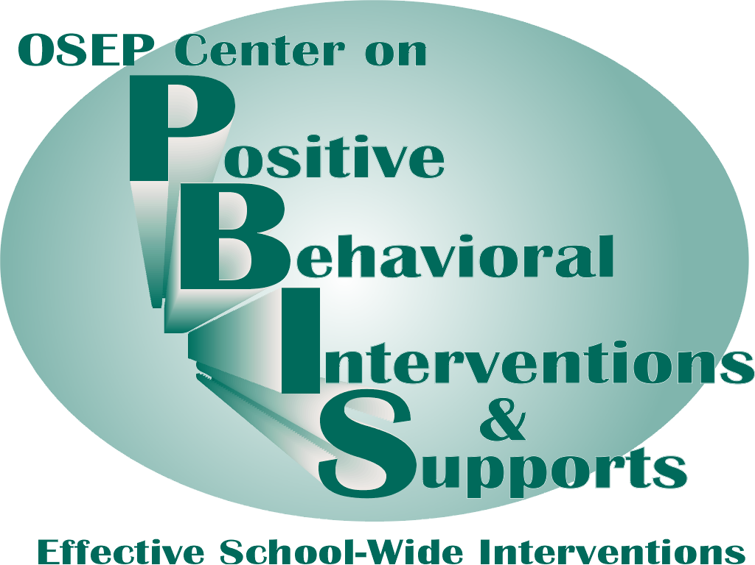 | 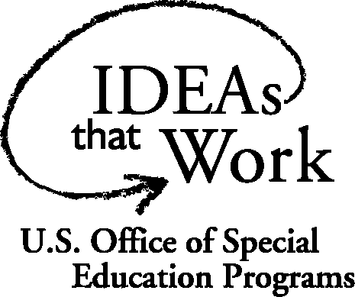
Classroom Management: Self-Assessment

Teacher__________________________ Rater_______________________ |  |  | Date_____________
Instructional Activity |  |  | Time Start_________  Time End _________
Tally each Positive Student Contacts | Total # | Tally each Negative Student Contacts |  | Total #
Ratio of Positives to Negatives: _____ to 1

Classroom Management Practice | Rating
- I have arranged my classroom to minimize crowding and distraction | Yes No
- I have maximized structure and predictability in my classroom (e.g., explicit classroom routines, specific directions, etc.). | Yes No
- I have posted, taught, reviewed, and reinforced 3-5 positively stated expectations (or rules). | Yes No
- I provided more frequent acknowledgement for appropriate behaviors than inappropriate behaviors (See top of page). | Yes No
- I provided each student with multiple opportunities to respond and participate during instruction. | Yes No
- My instruction actively engaged students in observable ways (e.g., writing, verbalizing) | Yes No
- I actively supervised my classroom (e.g., moving, scanning) during instruction. | Yes No
- I ignored or provided quick, direct, explicit reprimands/redirections in response to inappropriate behavior. | Yes No
- I have multiple strategies/systems in place to acknowledge appropriate behavior (e.g., class point systems, praise, etc.). | Yes No
- In general, I have provided specific feedback in response to social and academic behavior errors and correct responses. | Yes No
Overall classroom management score:  10-8 “yes” = “Super”  7-5 “yes” = “So-So”  <5 “yes” = “Improvement Needed” | # Yes________

Action Planning
The purposes of this assessment are to (a) determine the extent to which effective general classroom management practices are in place and (b) develop an action plan for enhancement/maintenance based on this information. This assessment and action plan can be completed as a “self-assessment” or by an observer.
- Pick a teacher-led/directed activity that has a specific learning outcome/objective.
- During the activity, count number of positive and negative student contacts that occur during the activity.
- After the activity,
  - Sum the number of positive and negative contacts and calculate the ratio of positive to negative contacts.
  - Assess whether each classroom management practice was evident.
  - Sum the number of “yes” to determine overall classroom management score.
  - Based on your score, develop an action plan for enhancement/maintenance.

Action Plan
# | Current Level of Performance | Enhancement/Maintenance Strategies

Selected Supporting References
Colvin, G., & Lazar, M. (1997). The effective elementary classroom: Managing for success. Longmont, CO: Sopris West.
Colvin, G., Sugai, G., & Patching, W. (1993). Pre-correction: An instructional strategy for managing predictable behavior problems. Intervention in School and Clinic, 28, 143-150.
Darch, C. B., & Kameenui, E. J. (2003). Instructional classroom management: A proactive approach to behavior management. (2nd ed.). White Plains, NY: Longman.
Jones, V. F. & Jones, L. S. (2001). Comprehensive classroom management: Creating communities of support and solving problems (6th ed.). Boston: Allyn & Bacon.
Kameenui, E. J., & Carnine, D. W. (2002). Effective teaching strategies that accommodate diverse learners (2nd ed.). Upper Saddle River, NJ: Merrill.
Latham, G. I. (1997). Behind the schoolhouse door: Eight skills every teacher should have. Utah State University.
Latham, G. (1992). Interacting with at-risk children: The positive position. Principal, 72(1), 26-30.
Martella, R. C., Nelson, J. R., & Marchand-Martella, N. E. (2003). Managing disruptive behaviors in the schools: A schoolwide, classroom, and individualized social learning approach. Boston, MA: Allyn & Bacon.
Paine, S. C., Radicchi, J., Rosellini, L. C., Deutchman, L., & Darch, C. B. (1983). Structuring your classroom for academic success. Champaign, IL: Research Press.

The Center is supported by a grant from the Office of Special Education Programs, with additional funding from the Safe and Drug Free Schools Program, US Department of Education (H326S980003). Opinions expressed herein are those of the authors and do not necessarily reflect the position of the US Department of Education, and such endorsements should not be inferred.
Revised from Sugai & Colvin
To calculate, divide # positives by # of negatives.
What? When? How? By When?

